

**PROTOCOL**to exercise

***Time Domain Reflectometry***

|  |  |  |
| --- | --- | --- |
| Class | Secretary | Signature |
| **4BHELS** | **HOFSTÄTTER A.** |  |
| Exercise- / Delivery date | Employee | Signature |
| 25th February 2015  4th March 2015 |  |  |
| Teacher | Employee | Signature |
| GRASINGER |  |  |
| Grade | **Employee** | Signature |
|  |  |  |
| ***Time Domain Reflectometry*** | | |
| **Used Devices**   |  |  |  |  |  | | --- | --- | --- | --- | --- | | Nr. | Device | Manufacturer | Type |  | | 1. | **Oscilloscope** | **-** |  |  | | 2. | **Function generator** | **-** |  |  | | | |

Inhalt

2 General Information 3

2.1 Given Exercises 3

3 Measurement of a RG58 Cable with 100 m length 4

3.1 Measurement the propagation speed 4

3.2 Open End 4

3.3 Short Circuit 5

3.4 Potentiometer 5

3.5 100 Ω 6

3.6 75 Ω 6

3.7 60 Ω 7

3.8 50 Ω 7

3.9 30 Ω 8

4 Cable with an unknown length 9

4.1 Open End 9

4.2 Short circuit 9

5 Measurement of an LAN Cable 10

5.1 Open End 10

5.2 Short circuit 10

5.3 Potentiometer 11

5.4 100 Ω 11

5.5 75 Ω 12

5.6 60 Ω 12

5.7 50 Ω 13

# General Information

Time-domain reflectometry or TDR is a measurement technique used to determine the characteristics of electrical lines by observing reflected waveforms

The spike pulse travels at the propagation speed to the end of the cable and if the end is unterminated (open end) it is reflected and travels back to the Oscilloscope!

At known cable length the propagation speed can be calculated. For coaxial cables it is about 2/3 of

the speed offlight in vacuum. At known propagation speed of the cable it is possible to calculate the

cable length.

If the cable has any defects (Impedance changes) it is possible to calculate the distance to the defect.

## Given Exercises

• Measure the propagation speed.

• Terminate the cable with different resistors (a Potentiometer) and determine the resistance with a minimum of reflections. This is the characteristic impedance of the cable.

• Measure the length of a cable with unknown length by using TDR

Three different wires were used for measurement

* RG58 Cable with 100 m length
* A random unknown length Cable
* A available LAN Cat 5e Cable, built-in wire

# Measurement of a RG58 Cable with 100 m length

## Measurement the propagation speed

The propagation time of the cable was 232 ns.

## Open End

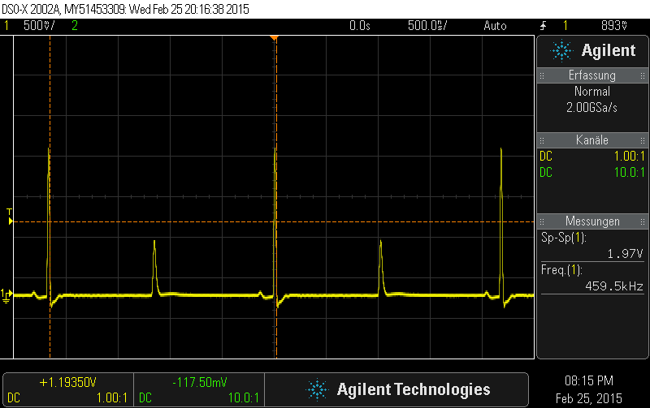

## Short Circuit

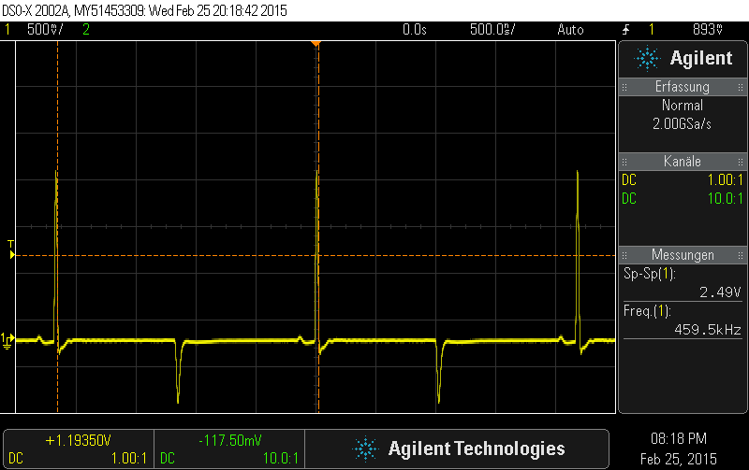

## Potentiometer

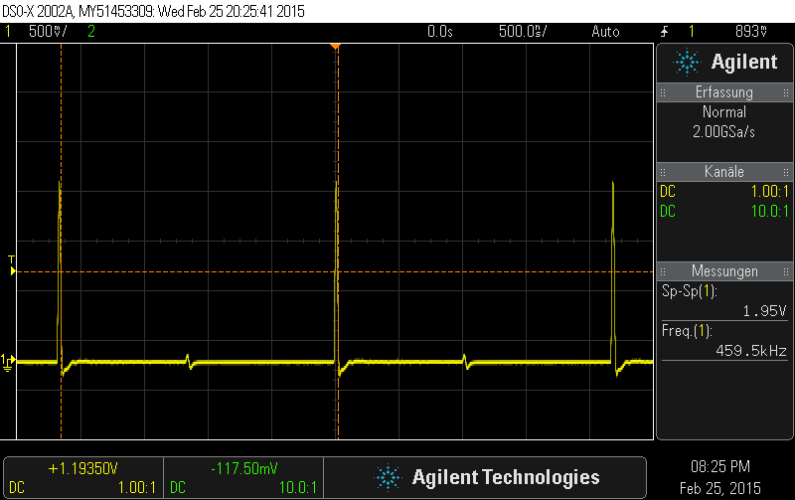

The right resistors value for the potentiometer which was set was .

## 100 Ω

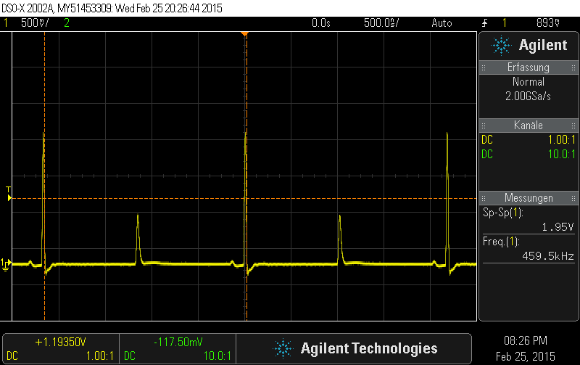

## 75 Ω

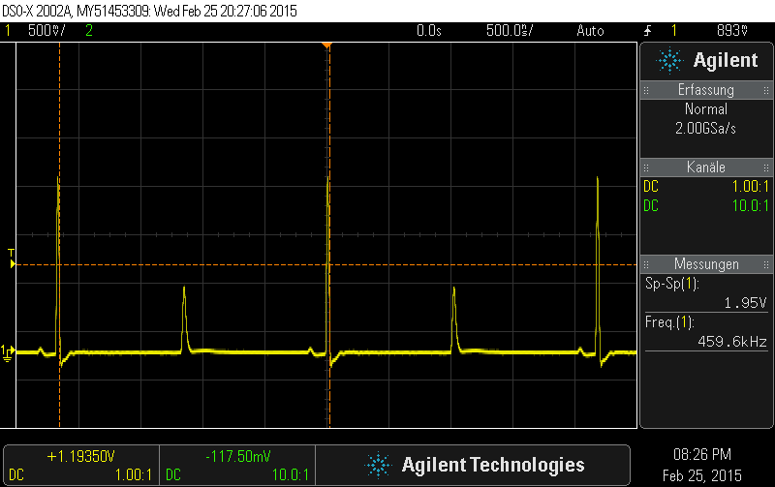

## 60 Ω

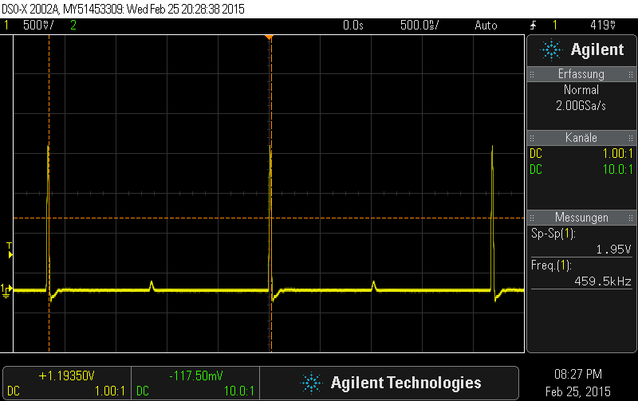

## 50 Ω

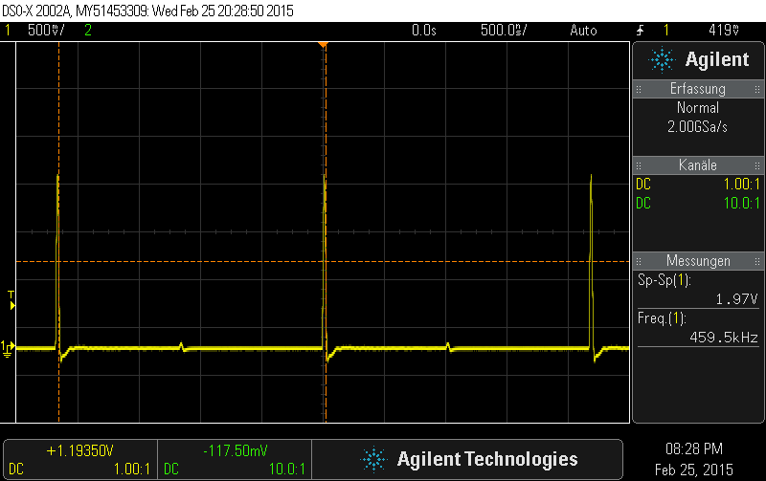

## 30 Ω

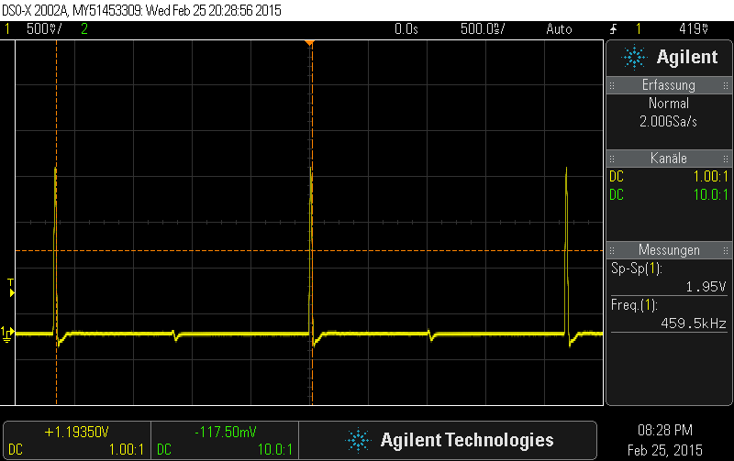

# Cable with an unknown length

## Open End

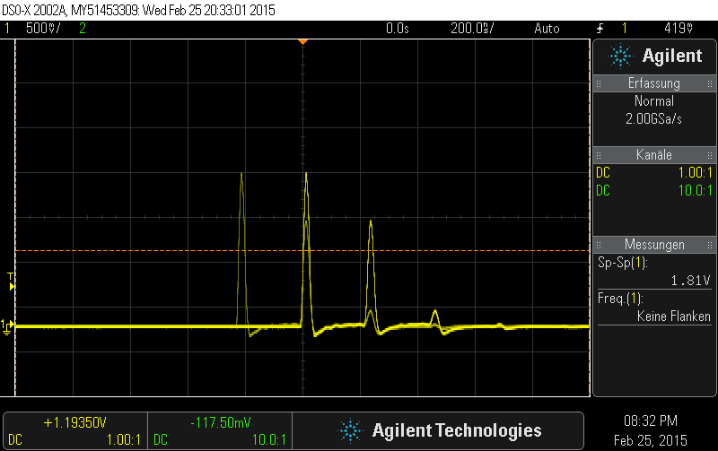

## Short circuit

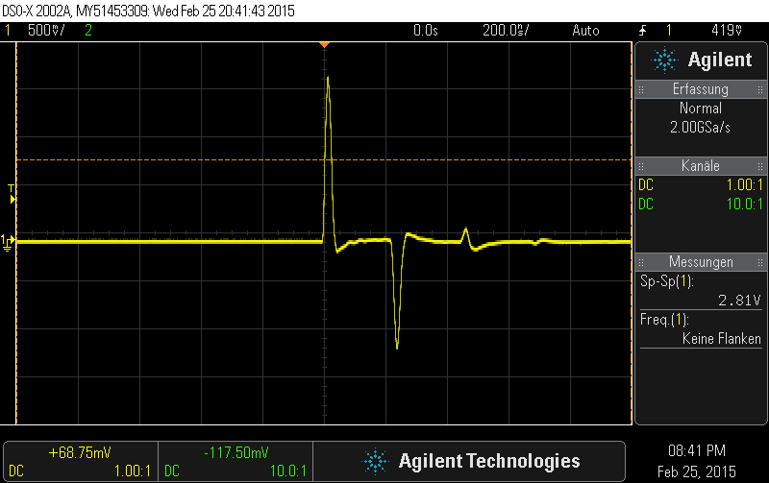

# Measurement of an LAN Cable

## Open End

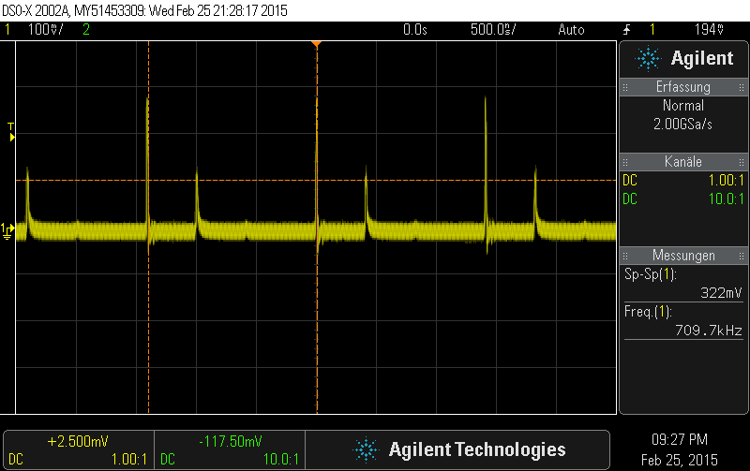

## Short circuit

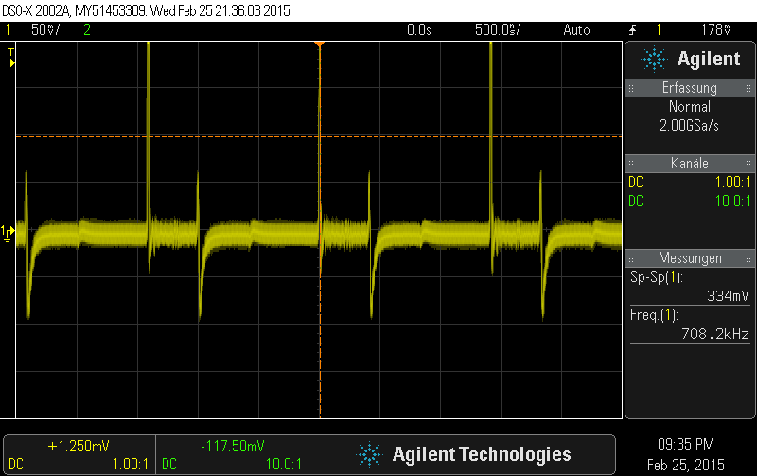

## Potentiometer

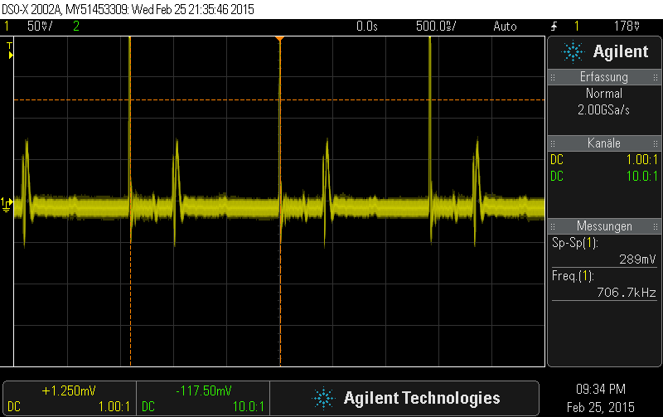

The measured resistance of the optimal potentiometer value was 71.5 Ω for the LAN cable.

## 100 Ω

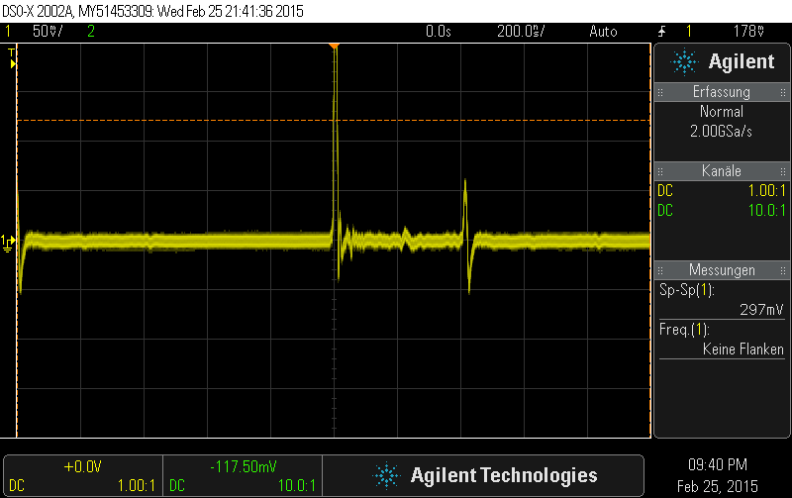

## 75 Ω

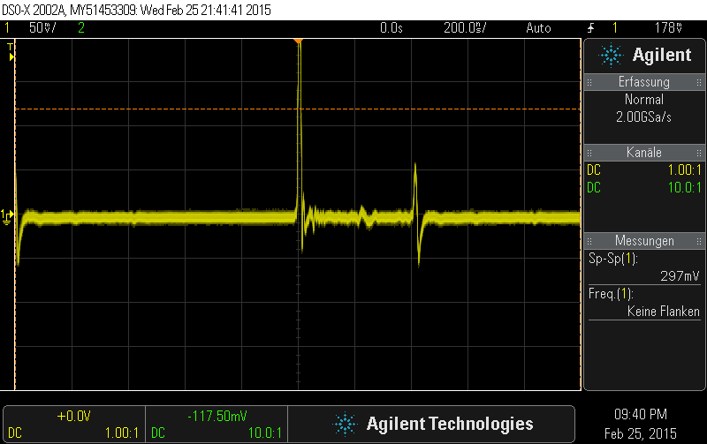

## 60 Ω

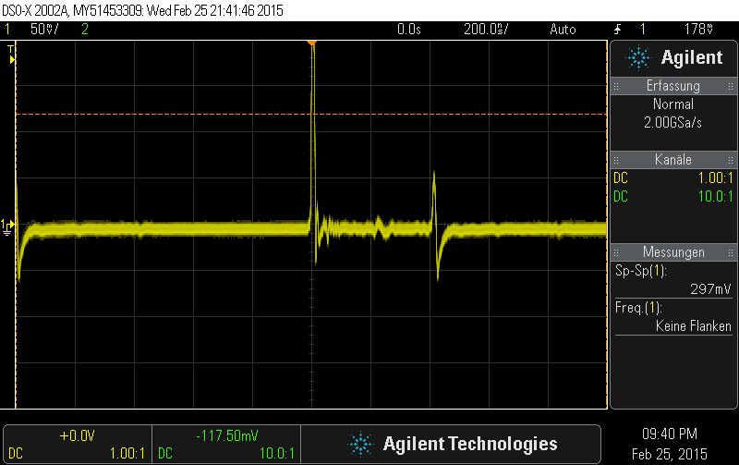

## 50 Ω

